Prepared Statement

scripts - V11__Create.sql, sql_generate.php, standart.sql, prepared.sql

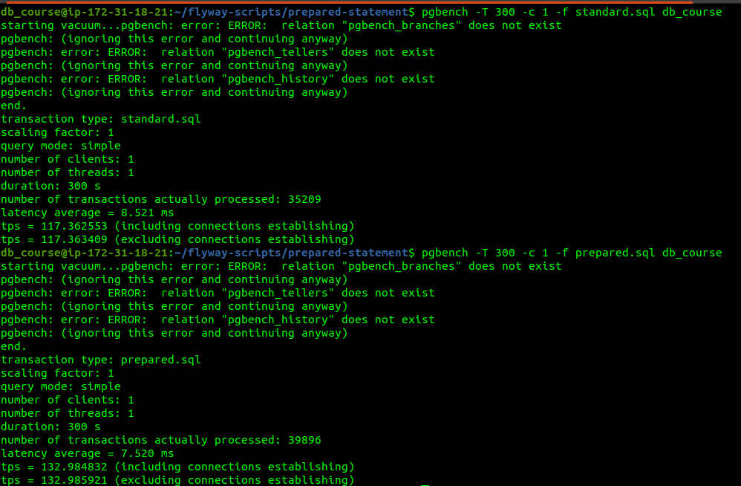

standart: tps = 117.363409 latency = 8.521 ms standard.sql  
prepared: tps = 132.985921 latency = 7.520 ms prepared.sql

graphic of latency for both scripts (ms)  
  
